 CHEMICAL ENGINEERING TRANSACTIONS  VOL. 95, 2022 | A publication of  
The Italian Association
of Chemical Engineering
Online at www.cetjournal.it

Guest Editors: Selena Sironi, Laura Capelli
Copyright © 2022, AIDIC Servizi S.r.l.
ISBN 978-88-95608-94-5; ISSN 2283-9216

Portable instrumental odour monitoring system for Air Quality Monitoring by citizens in Outdoor Environments
Sergio Palomeque-Mangut¹, Félix Meléndez¹, Jaime Gómez-Suárez¹, Patricia Arroyo¹, José Pedro Santos, Jesus Lozano^{1,}*
¹ Escuela de Ingenierías Industriales, Universidad de Extremadura, Badajoz (Spain)
² Instituto de Tecnologías Físicas y de la Información, CSIC, Madrid (Spain)
(*) jesuslozano@unex.es
Air pollution is a major contributor to the global disease burden. Scientific literature has been consistent for the past decades, exposing the dangers behind hazardous air quality in both indoor and outdoor environments, and its impact on human health and ecosystems. Conventional monitoring stations are expensive and bulky, limiting the spatiotemporal resolution of the provided data. For this reason, administrations are interested in adding low-cost sensors to the monitoring network, and thus obtaining measures from multiple sources to enhance the network’s density and coverage. In this work, we present a portable Instrumental Odour Monitoring System (IOMS) consisting of an electronic device with an array of metal oxide semiconductor (MOS) gas and Particle Matter sensors connected through Bluetooth with a smartphone with our own developed app that gathers data and sends it to a cloud. We tested the device in two different experimental setups, the first with laboratory-controlled conditions and the second in field, creating a network with the help of volunteers in the city of Barcelona.
  - Introduction
Scientific literature has been consistent for the past decades, showing the dangers behind exposure to air pollution both in indoor and outdoor environments. For that reason, policy makers and environmental agencies have a strong need for measuring the concentration of pollutants in certain areas, so that they can take preemptive countermeasures and inform the public on certain precautions. One of the problems when facing this issue are the costs of conventional air quality monitoring equipment. These instruments provide accurate data about the presence of pollutants, but their price and size are large. Therefore, their use in cities is limited to a few locations, creating a network of monitors with poor spatial and time resolution.

An article published in The Lancet in 2017 determined that long-term exposure to ambient fine particles caused 4.2 million deaths in just one year (Cohen et al., 2017). Subsequent studies have shown this number of casualties to be even larger and persist in considering air pollution one of the top leading risk factors for mortality globally. The last approximation made by the World Health Organization estimates that 8 million deaths are attributable to both exposure to ambient outdoor air pollution and household’s smokes. When considering the actions from institutions, it’s important to consider that air quality monitoring equipment’s are expensive and bulky. Therefore, there is a limit in the number of locations that we can measure, and that’s why low-cost sensing technologies have been gathering a great deal of attention.

The WHO Air quality guidelines serves as base for legislation on limiting the maximum permitted concentration of these substances in urban air. Air Quality Index is used by local governments for activating restricted traffic protocols or publishing informative maps. Monitoring equipment that cities are installing can be relatively small stations or robust compact systems, but due to their nature they are not suitable for citizens to use. Low-cost sensor platforms, designed to be carried by citizens, are being studied as potential sensor nodes in a dense air quality monitoring network (Castell et al., 2017). With such a network, large urban areas can be mapped with higher density of measures. A recent report by the World Meteorological Organization (WMO) comprehensively examines a range of low-cost gas sensors for air quality monitoring (Lung et al., 2018). Among these, metal oxide semiconductor (MOS) gas sensors stand out.

In this paper, we present a novel low-cost sensor platform that integrates five commercial metal oxide semiconductor (MOS) gas sensors and an optical particle counter. Ours is a fully-custom designed embedded system, which does not rely on modularity, or Arduino boards. Other related works reported in the literature also make use of BLE and smartphones for environmental monitoring in wearable applications (Haghi et al., 2018). However, these are based in older gas sensing technologies, do not integrate PM sensing capabilities, and their performance was not validated with field testing. Our device sends all collected data to a smartphone through Bluetooth communications, where our own developed application displays an evaluation of the quality of the surrounding air and sends it to a cloud service.
  - Materials and methods
    - Device overview
The portable IOMS presented in this work is comprised of a custom designed printed circuit board (PCB), a 3.7 V lithium-ion battery, a particulate matter (PM) sensor, and a smartphone device. It can function as a sensor node in a wireless sensor network, with the smartphone transmitting across the Internet the collected data, gathered from the five integrated MOS sensors and the PM sensor. The system is based on a 32-bit PIC32MM0256GPM048 microcontroller unit (MCU) from Microchip. This unit coordinates sensors measurements through two I2C serial interfaces and one UART connection, while also managing Bluetooth LE communications thanks to Microchip's RN4871 low-energy module.

The samples are sent in order to be processed by the developed smartphone's app, allowing us to check the sampled values in real time and store them in a file for later processing. All components are soldered on the PCB except for the Honeywell HPM particulate matter sensor and the Li‐ion battery. The device is battery powered and can easily be recharged through a microUSB-B plug. While working, the device draws 290 mA from the battery. The five integrated digital MOS commercial gas sensors, portrayed in Table 1, provide several variables each. Besides the raw resistor signal, sensors incorporate algorithms that process raw values and output predictions of equivalent CO₂ and total VOCs.

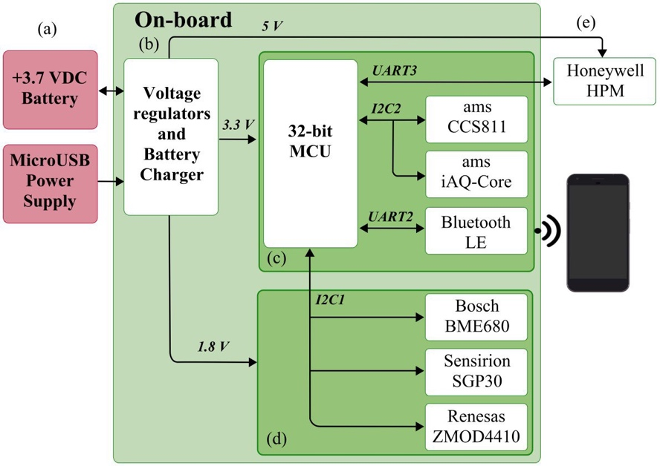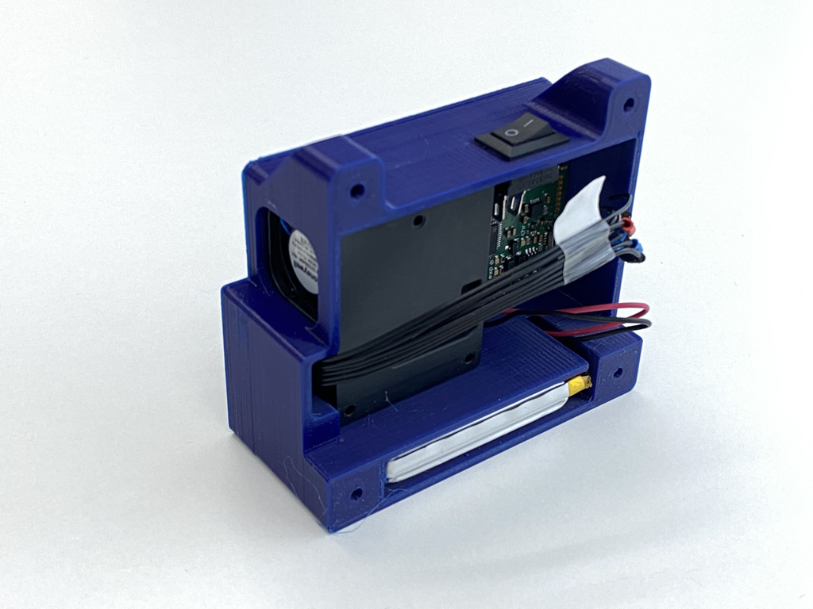
Figure 1: Block diagram (left) and device embedded in a 3D-printed case (right) of the prototype of portable IOMS.
Table 1: Characteristics of the device’s sensors
Sensor | Manufacturer | Signals
CCS811 | ScioSense | eCO₂, TVOC, Resistance
iAQ-Core | ScioSense | eCO₂, TVOC, Resistance
BME680 | Bosch | T, P, RH, Resistance
SGP30 | Sensirion | eCO₂, TVOC, H₂, EtOH
ZMOD4410 | Renesas | eCO₂, TVOC, iAQ, Resistance
HPMA115S0-XXX | Honeywell | PM_{2.5}, PM₁₀
    - App overview
The mobile application, named aQtracer (Figure 2), was developed for Android devices and implemented in Dart using the Flutter framework. The simple interface is intuitive, as it is destined for users. First, once the characteristic has been selected, the application sends a programmed command from our ASCII communication protocol and starts listening to the measurements data packages. The whole data set sent by the IOMS, along with the smartphone's GPS latitude and longitude parameters are sent in real time to the cloud in order to be stored and viewed. At the same time, two values are displayed on the screen in real time: an air quality value (iAQ) from the ZMOD4410 gas sensor and a PM measure from the HPM sensor. These two values serve as guidelines for the users, indicating the overall quality of their surrounding air. The iAQ signal, which is calculated and outputted by the ZMOD4410, should not be mistaken with the more robust air quality index (AQI) that we use later on and which is calculated by machine learning algorithms. The values are represented in graphs with a color palette and accompanied by clear health advise.

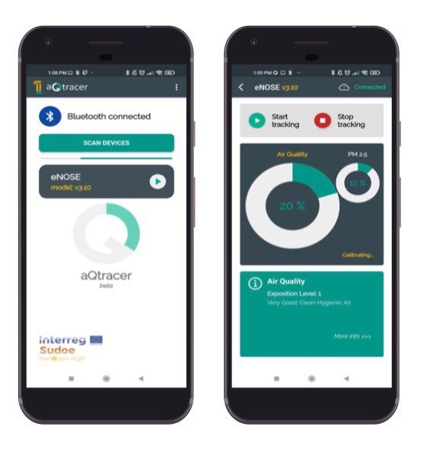
Figure 2: Screen capture of the main screens of the developed app.
    - Wireless sensor network
The most efficient solution to obtain measurements of a high number of locations is by means of wireless sensor networks (WSN) (Arroyo et al. 2018, Arroyo et al. 2019). With the increasing acquisition of smart personal mobile devices with Internet connection, such as smartphones, it is interesting to consider their incorporation into this kind of systems. In this way, each mobile device user could be view as a sensor node integrated in a wireless network. This would create a higher resolution air quality indicative map. For this purpose, the air quality measurement device must be small, so that it can be easily carried and does not cause any inconvenience to the holder or citizen. In this regard, Mobile Sensing Systems (MSS) have emerged, which are mobile sensor systems made up of smartphones (to control the sensors), a web server to store data, and the use of protocols and cloud computing to send and retrieve the data. These systems have been reviewed by several authors (Laport-López et al., 2019, Khan et al., 2013, Macias et al. 2013).
    - Experimental setups
The devices were tested in two distinct environments: laboratory and in field conditions. First, we exposed them to laboratory-controlled gas concentrations using the calibration instrument Model 714 NO₂/NO/O₃ Calibration Source by 2B Technologies (Boulder, Colorado, US). Second, a measurement campaign done by voluntary citizens in Barcelona Metropolitan Area (Feb. 22 – May 7, 2021).
  - Experimental results
    - Laboratory measurements
First, the system was tested in a controlled environment using the calibration instrument Model 714 NO2/NO/O3 Calibration Source by 2B Technologies, US. The designed device was contained in a hermetic box with two bulkhead fitting for inlet and outlet air. An inlet tube connected the calibration instrument to the hermetic box and, thanks to the outlet tube, provided an air flow with calibrated concentrations in parts per billion of the mentioned gases. Therefore, it was possible to determine the response of the sensors array to two major outdoor air pollutants: NO₂ and O₃.

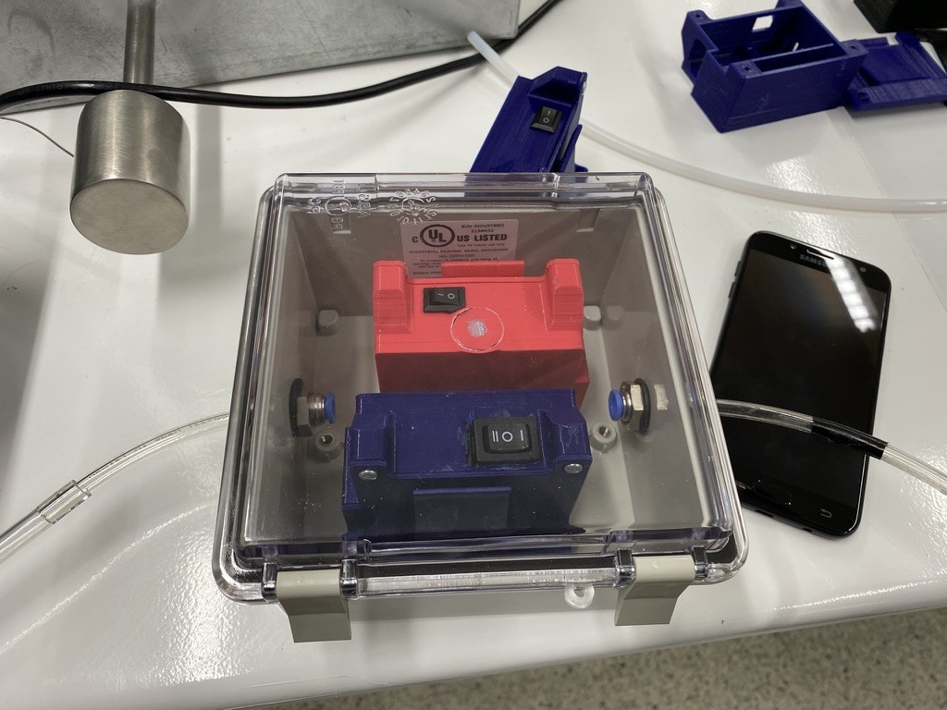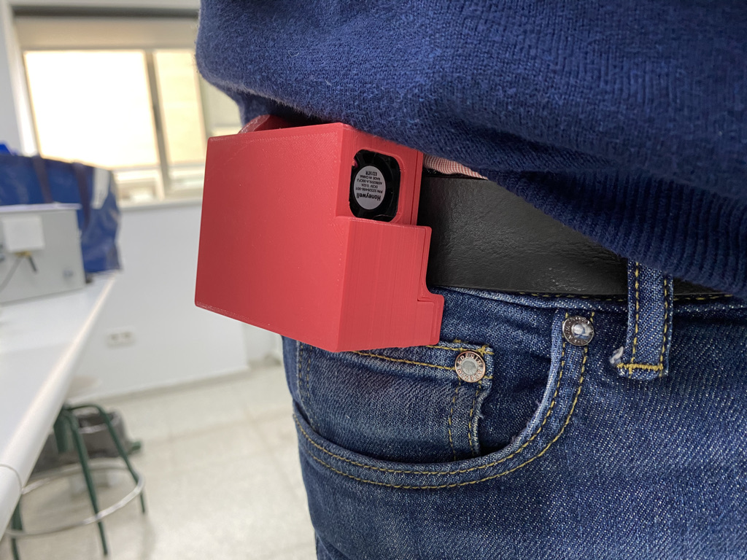
Figure 3: Experimental setups for validation, in laboratory-controlled conditions (left) and in field campaigns carried by one of the users(right).
The response of the raw signals of all five sensors and the concentration values used in the experiment are all shown in Figure 4 left. The fingerprint for each concentration and pollutant allows to compare the response of the sensors. The chart proves that the device is capable of distinguishing between NO₂ and O₃ at different concentration levels, with sensors producing differentiated responses for each pollutant.
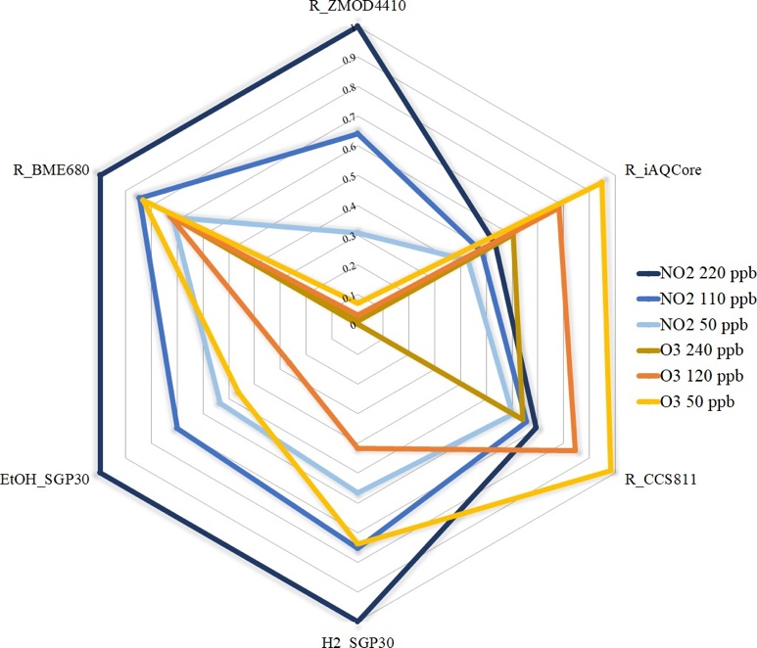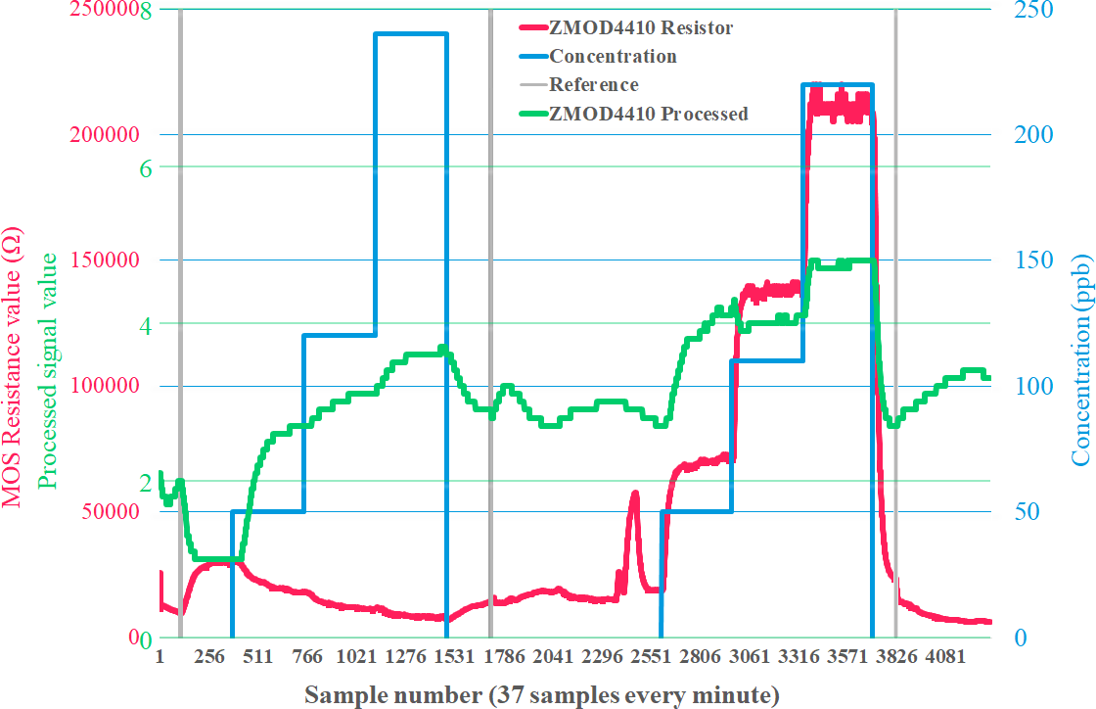
Figure 4. Radial plot with the normalized response of the five integrated MOS gas sensors (left) and temporal response curves of the ZMOD4410in the test experiment in lab.
Figure 4 right shows the temporal response of some of the sensors used for calculating the Air Quality Index. The reference lines (in grey) are used to distinguish the phases of the experiment. After the first reference line, the hermetic box was closed and the calibration instrument emitted clean air for seven minutes before starting the sequence of O₃ at concentrations of 50 ppb, 120 ppb and 240 ppb (in blue). Each step lasted ten minutes. When the sequence finished, the box remained open for three minutes. After the second line, the process was repeated with NO₂. After the third line, the box was opened. The evolution of both the raw resistance signal in ohms (coloured red) and the dimensionless processed iAQ signal (coloured green) are presented.

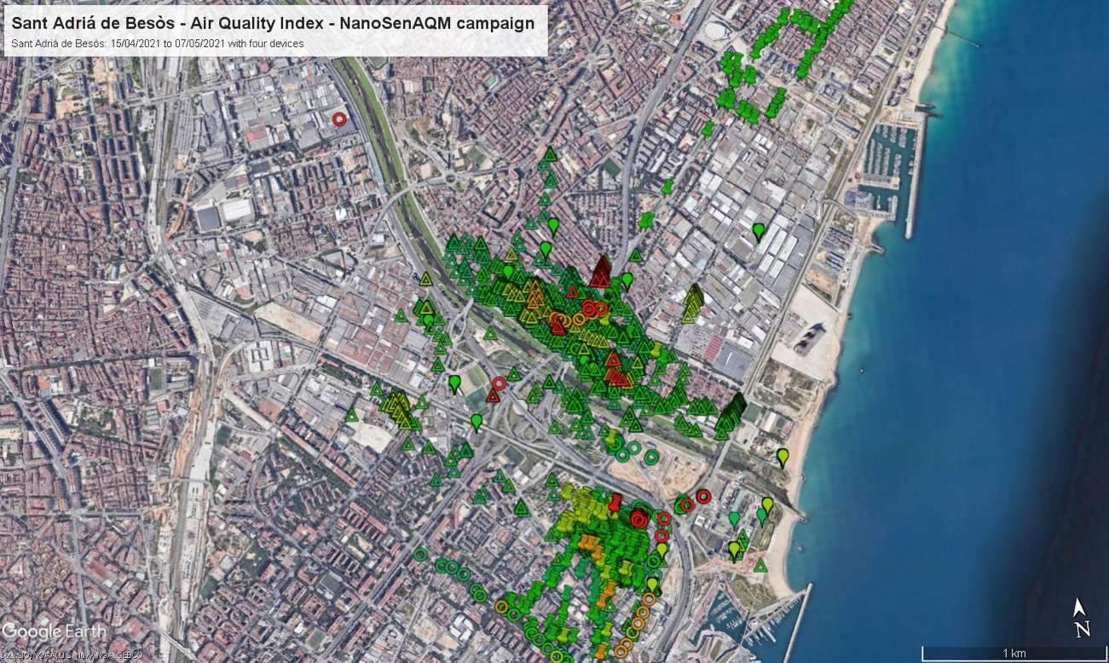
Figure 5. Map of the Barcelona metropolitan area (North), showing Air Quality Index values gathered by several volunteers carrying the designed devices.
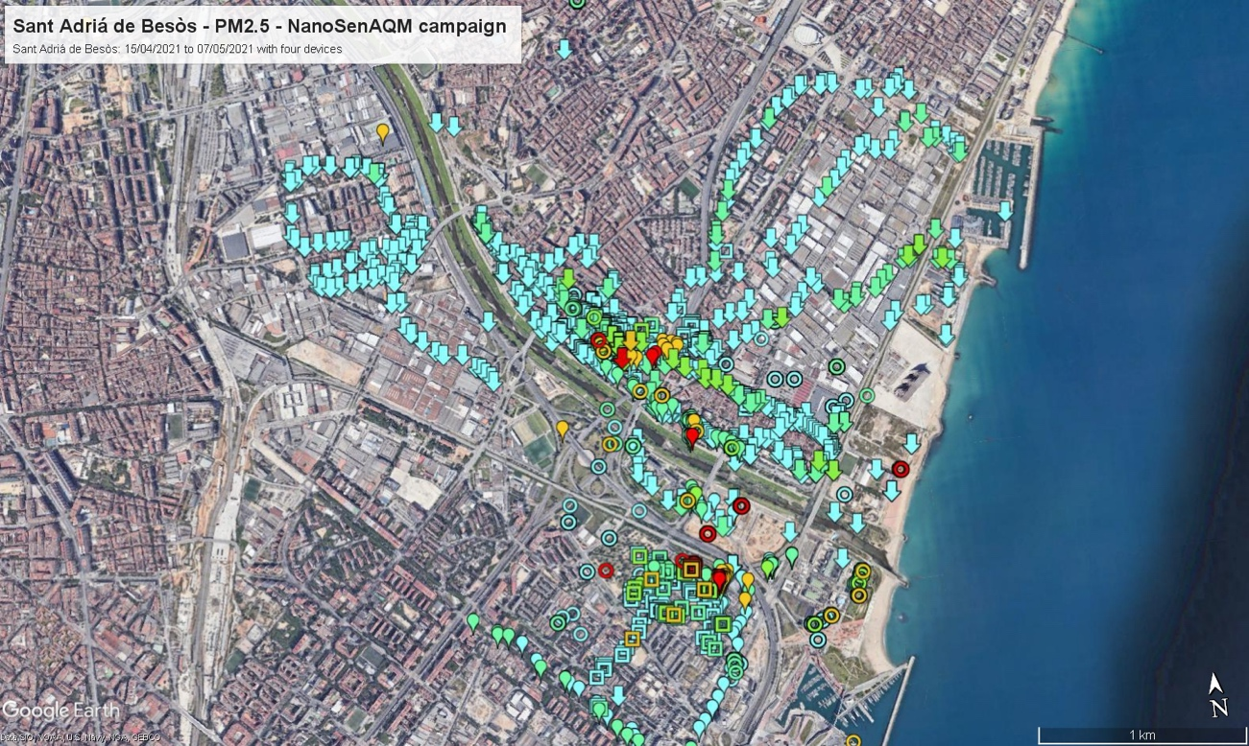
Figure 6. Map of the Barcelona metropolitan area (North), showing PM2.5 values gathered by several volunteers carrying the designed devices.
    - Campaign at Barcelona
Having verified the device’s response to two major outdoor air pollutants, four devices were deployed for field testing in a campaign at Sant Adrià de Besòs with the help of some volunteers. To see the spatial distribution of the measurements, some of the values obtained, as an example, have been plot in a map. Figure 5 and Figure 6 show the Air Quality Index (AQI) for gases and PM2.5 respectively. In the map, each point represents a value collected at a certain time instant. The different symbols represent devices, whereas the color indicates the value’s range of Air Quality Index (Cyan - good, green - reasonably good, yellow - fair, red - unfavourable, brown - very unfavourable, violet - extremely unfavourable).

The color scheme is obtained by applying pattern recognition analysis over the collected data. First, we trained a multi-layer perceptron (MLP) feedforward artificial neural network (ANN) with the laboratory measurements, which included humidity and temperature correction from the measures taken by the BME680. We neglected the AQI predicted by the BME680, since we are only interested in the raw response of the sensing elements. This laboratory MLP regressor is then feed into a new MLP classifier along with the dataset from the field campaign, which are represented in Figure 5 and Figure 6. Both algorithms output a scalar value between 1 to 6, corresponding to the color values mentioned earlier.
  - Conclusions and Future Works
In this paper, a low-cost, low-consumption and very small size Instrumental Odour Monitoring System has been used for air quality monitoring. These devices in combination with smartphones allows the creation of a wireless sensor network for creating air quality maps in which each citizen acts as a node of a huge network with a very high number of nodes. We have presented this platform for air quality monitoring and successfully deployed it in the field with volunteers in the city of Barcelona. The system can easily be extended to create urban networks that can monitor pollution events with improved spatial resolution. Additionally, the device informs each user of the air quality level in the nearby area and give advice for a better health and raise awareness about the importance of air quality. Future tests with pollutants and odours could be performed to adjust the calibration algorithms to create pollutants and odour maps.
Acknowledgments
Authors want to thank the European Union for supporting NanoSen-AQM (SOE/P1/E0569) project and volunteers from the Metropolitan Area of Barcelona for using our devices.
References
Arroyo, P.; Lozano, J.; Suárez, J.I. Evolution of Wireless Sensor Network for Air Quality Measurements. Electronics 2018, 7, 342. https://doi.org/10.3390/electronics7120342
Arroyo, P.; Herrero, J.L.; Suárez, J.I.; Lozano, J. Wireless Sensor Network Combined with Cloud Computing for Air Quality Monitoring. Sensors 2019, 19, 691. https://doi.org/10.3390/s19030691
Castell, N., Dauge, F. R., Schneider, P., Vogt, M., Lerner, U., Fishbain, B., Broday, D., & Bartonova, A. (2017). Can commercial low-cost sensor platforms contribute to air quality monitoring and exposure estimates? Environment International, 99, 293–302. https://doi.org/10.1016/j.envint.2016.12.007
Cohen, A. J., Brauer, M., Burnett, R., Anderson, H. R., Frostad, J., Estep, K., Balakrishnan, K., Brunekreef, B., Dandona, L., Dandona, R., Feigin, V., Freedman, G., Hubbell, B., Jobling, A., Kan, H., Knibbs, L., Liu, Y., Martin, R., Morawska, L., … Forouzanfar, M. H. (2017). Estimates and 25-year trends of the global burden of disease attributable to ambient air pollution: an analysis of data from the Global Burden of Diseases Study 2015. The Lancet, 389(10082), 1907–1918. https://doi.org/10.1016/S0140-6736(17)30505-6
Haghi, M., Stoll, R., & Thurow, K. (2018). A Low-Cost, Standalone, and Multi-Tasking Watch for Personalized Environmental Monitoring. IEEE Transactions on Biomedical Circuits and Systems, 12(5), 1144–1154. https://doi.org/10.1109/TBCAS.2018.2840347
W. Z. Khan, Y. Xiang, M. Y. Aalsalem and Q. Arshad, "Mobile Phone Sensing Systems: A Survey," in IEEE Communications Surveys & Tutorials, vol. 15, no. 1, pp. 402-427, First Quarter 2013, doi: 10.1109/SURV.2012.031412.00077.
Laport-López, F., Serrano, E., Bajo, J. et al. A review of mobile sensing systems, applications, and opportunities. Knowl Inf Syst 62, 145–174 (2020). https://doi.org/10.1007/s10115-019-01346-1
Lung, C., Jones, R., Zellweger, C., Karppinen, A., Penza, M., Dye, T., Hüglin, C., Ning, Z., Leigh, R., Hagan, D. H., Laurent, O., & Carmichael, G. (2018). Low-cost sensors for the measurement of atmospheric composition: overview of topic and future applications. In Wmo (Issue May). http://www.wmo.int/pages/prog/arep/gaw/documents/Draft_low_cost_sensors.pdf
Macias, E.; Suarez, A.; Lloret, J. Mobile sensing systems. Sensors (Switzerland) 2013, 13, 17292–17321.

